1. 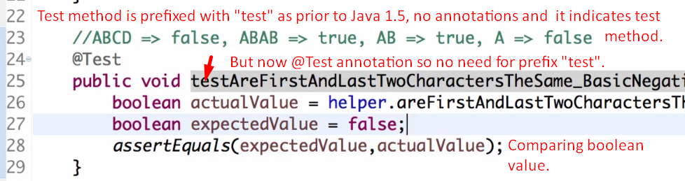
2. assertFalse(), assertTrue()  
   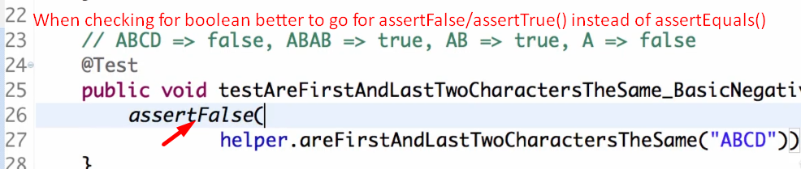
3. 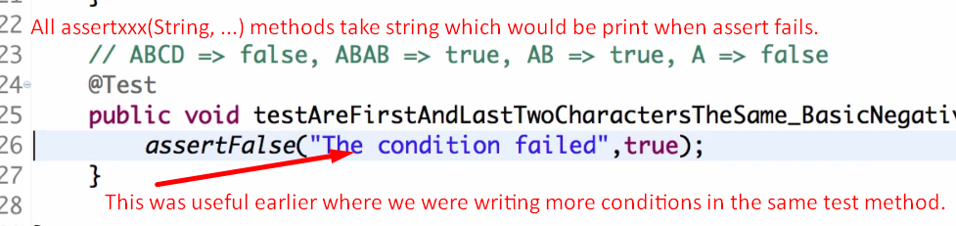**NOTE**: Now for each failed test, the exact method name is printed so no need for string version of assertXXX( String version).
4. Method name in the following case: **testAreFirstAndLastTwoCharactersTheSame_BasicNegativeScenario()**
5. 